The Beatles - Let it be 1970 (tonalité originale) BPm : 70
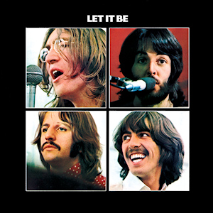

C G Am F
When I find myself in times of trouble Mother Mary comes to me
C G F* C
Speaking words of wisdom, let it be.
0---------
1----0-1-
0-------2-
2----0----

C G Am F
F*

And in my hour of darkness she is standing right in front of me
C G F* C
Speaking words of wisdom, let it be.

Am G F C C G F* C
Let it be, let it be, let it be, let it be. Whisper words of wisdom, let it be.

C G Am F
Rythme de base:
B . B Bh
1 2 3 4

And when the broken hearted people living in the world agree,
C G F* C
There will be an answer, let it be.
C G Am F
For though they may be parted there is still a chance that they will see
C G F* C
There will be an answer, let it be.

Am G F C C G F* C
Let it be, let it be, let it be, let it be. There will be an answer, let it be.
Am G F C C G F* C
Let it be, let it be, let it be, let it be. Whisper words of wisdom, let it be.

F* C Bb F G F C (x2)
(Solo de guitare)

Am G F C C G F* C
Let it be, let it be, let it be, let it be. Whisper words of wisdom, let it be.

C G Am F
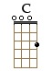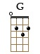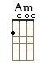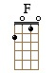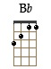
And when the night is cloudy there is still a light that shines on me,
C G F* C
Shine on until tomorrow, let it be.
C G Am F
I wake up to the sound of music Mother Mary comes to me
C G F* C
Speaking words of wisdom, let it be.

Am G F C C G F* C
Let it be, let it be, let it be, let it be. There will be an answer, let it be. (x2)
Am G F C C G F* C
Let it be, let it be, let it be, let it be. Whisper words of wisdom, let it be.

F* C Bb F G F C (x2)
G / V1 Top 5

